**Experiment 3**

**Aim –** Find the average and sum of array of N numbers entered by user.

**Theory–**

**Program**

**package** govind;

**import** java.util.Scanner;

**public** **class** N_avg {

**public** **static** **void** main(String[] args) {

Scanner scanner = **new** Scanner(System.***in***);

System.***out***.print("Enter the number of elements in the array: ");

**int** n = scanner.nextInt();

**int**[] numbers = **new** **int**[n];

System.***out***.println("Enter the " + n + " numbers:");

**for** (**int** i = 0; i < n; i++) {

numbers[i] = scanner.nextInt();

}

**int** sum = 0;

**for** (**int** num : numbers) {

sum += num;

}

**double** average = (**double**) sum / n;

System.***out***.println("Sum of the numbers: " + sum);

System.***out***.println("Average of the numbers: " + average);

}

}

**Output:**

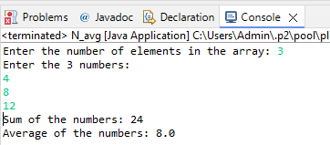

**Learning Outcome:**